Experiment 4

NAME: SAP ID:

Aim: Create dual axis charts and table calculations, bins, distributions and create Heat maps

Dual Axis Charts:

A dual axis chart is a great way to easily illustrate the relationship between two different variables. They illustrate a lot of information with limited space and allow you to discover trendsyou may have otherwise missed if you’re switching between graphs. Synchronizing Dual Axis charts is very important in most cases.

**Examples of Dual Axis Charts**

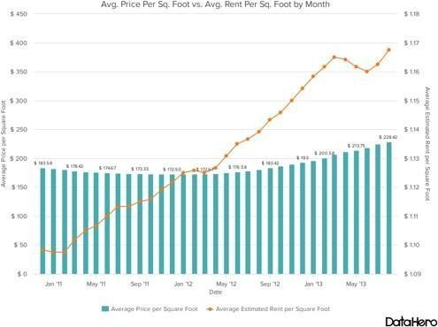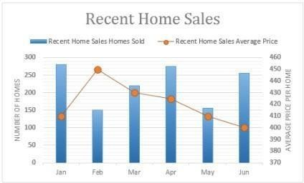

Table Calculations:

A table calculation is a transformation you apply to the values in a visualization. Table calculations are a special type of calculated field that computes on the local data in Tableau.They are calculated based on what is currently in the visualization and do not consider any measures or dimensions that are filtered out of the visualization.

You can use table calculations for a variety of purposes, including: Transforming values to rankings

Transforming values to show running totals

Bins:

Any discrete field in Tableau can be considered as a set of bins. For example, suppose you create a view with **Profit** on **Rows** and **State**on **Columns**. You could consider the **State** field as aset of bins—each profit value is sorted into a bin corresponding to the state from which the value was recorded. But if you want to see values for **Profit** assigned to bins without reference to a dimension, you can create a numeric bin, with each individual bin corresponding to a rangeof values.

Heat Maps:

A heat map is a two-dimensional representation of data in which values are represented bycolors. A simple heat map provides an immediate visual summary of information. More elaborate heat maps allow the viewer to understand complex data sets.

There can be many ways to display heat maps, but they all share one thing in common

-- theyuse color to communicate relationships between data values that would be would be much harder to understand if presented numerically in a spreadsheet.

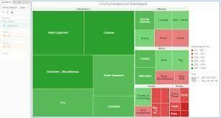In the United States, many people are familiar with heat maps from viewing television news programs. During a presidential election, for instance, a geographic heat map with the colorsred and blue will quickly inform the viewer which states each candidate has won.

Lab Assignments to complete in this session

Use the given datasets and perform the following task: -

Dataset: https://data.world/annjackson/world-indicators-tableau

The UN also has an Advisory Role. It advises countries on things that require improvement/change. Use a Highlight table to find if any of the countries that large population require changes. The Highlight table would be used to compare the parameters with other countries in order to evaluate if anomalies are resent.

Health and/or Development Metrics should be used for the same

SCREENSHOTS:

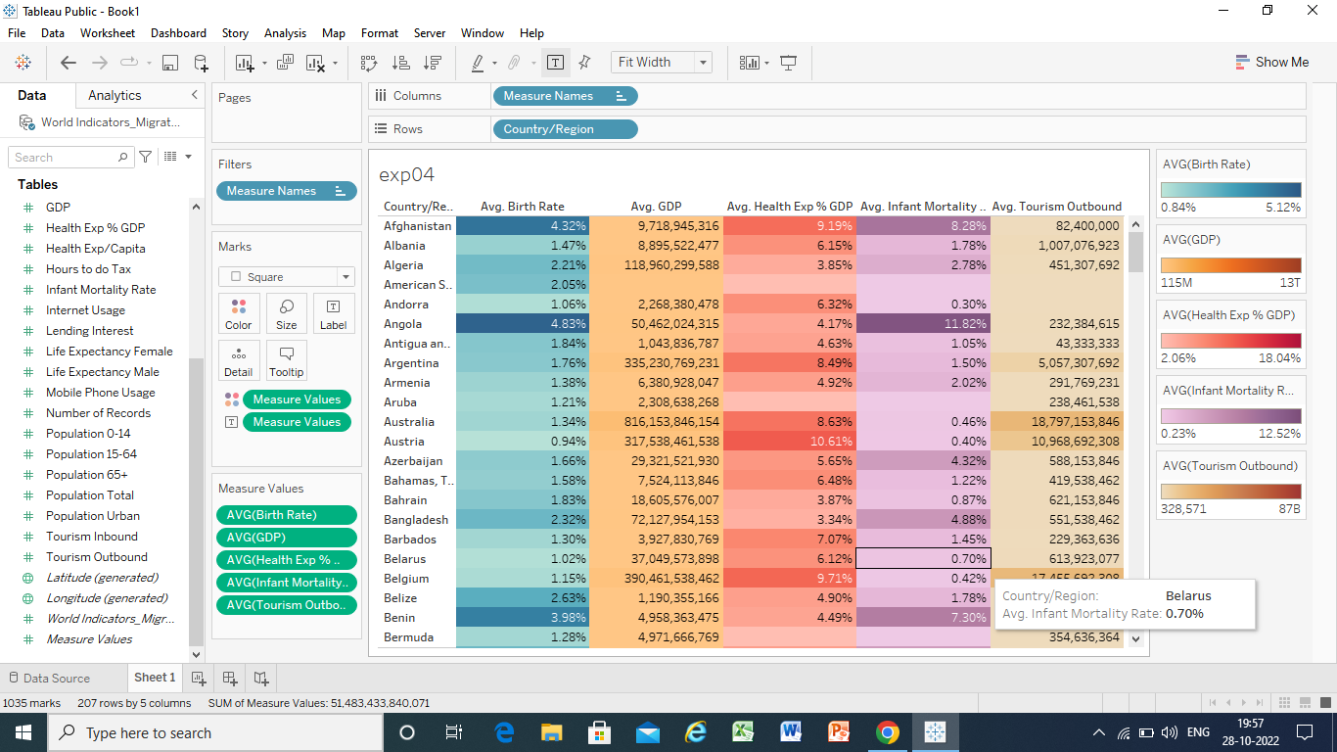

FOR TOP 10 COUNTRIES BY POPULATION:

